Exercise 5

1. Develop a JavaScript program that displays the images of baseball based on the user’s input. The user can input the side length and choose to draw a triangle or to draw a square. The expected user interfaces are as follows: (The image file is *baseball.jpg.* Should re-size the image to 50x50px)



If choosing “Draw Baseball Square”

If choosing “Draw Baseball Triangle”

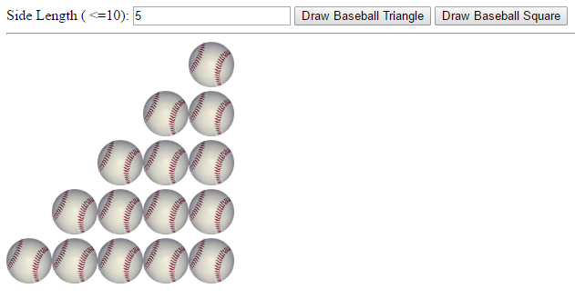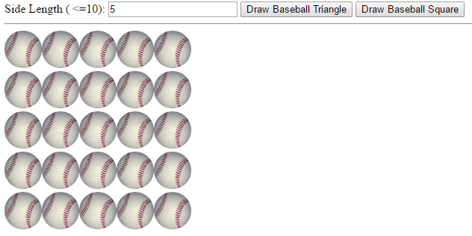

Besides, if the user inputs an invalid value (< 0 or >10), this program will show a popup dialog, and set the input value as the default value 5.

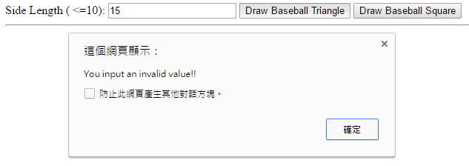



**Hint**:

* The images are suggested to be shown in a *div* element.
* Suggest to use “*blank.png*” to leave spaces to build correct triangles.

1. Revise Fig. 9.5 in our text book to show additional message and image describing the following conditions:
   * Detect "一色": four dice have the same face values

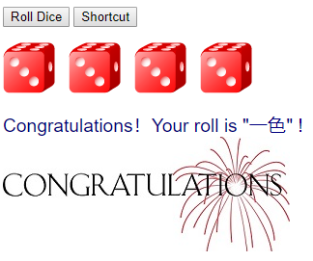

* + Detect "無面": the face values of four dice are totally different

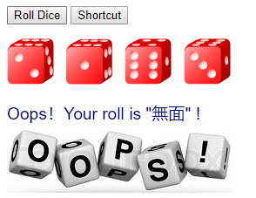

* + Detect "No decision": other conditions

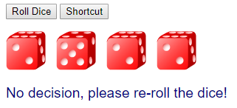

* + Add a new button “Shortcut” to directly produce the result of "一色".

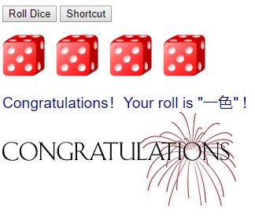

Other requirements:

* The message is in navy color and 120% size.
* Set "font-family" to *Helvetica, "Microsoft YaHei", "LiHei Pro", TW-Kai*

**Hint**:

* Please carefully study Fig. 9.5 and make use of variables: *die1Value, die2Value, die3Value,* and *die4Value.*
* Array is not required. (But using array is acceptable)

**Rules of this game**: <https://zh.wikipedia.org/wiki/十八仔>

**Bonus** (+2):

* + Compute the score based on the game rules:

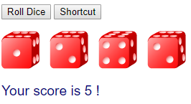

* + Detect "十八":

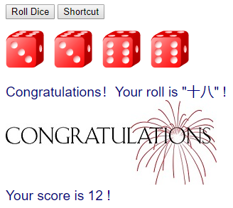

* + Add a new button “Shortcut2” to directly produce the result of "十八".

